**Using setprecision(int) and system(“pause”)**

#include "stdafx.h"

#include <iostream>

#include <iomanip>

using namespace std;

int main()

{

double jax = 8712.654;

//first output

cout << setprecision(2) << fixed;

cout << jax << endl << endl;

//second output

cout << setprecision(3) << jax << endl << endl;

system("pause");

cout << "This text should appear after the pause...";

}

**Result:**

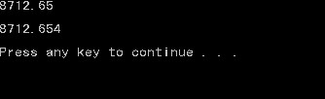After a click

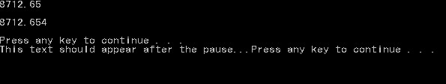

**Important notes:**

* The library used is <iomanip>
* When setting a precision, “<<fixed” will make the default precision to any number
* Use system(“pause”); to pause the program during runtime